1. Make sure that ‘AdventureWorks2014’ database is installed on the destination machine
2. Clone ‘AW2014_Exercise’ repository from GitHub address ‘https://github.com/FAshkani/AW2014_Exercise.git’ on your destination computer

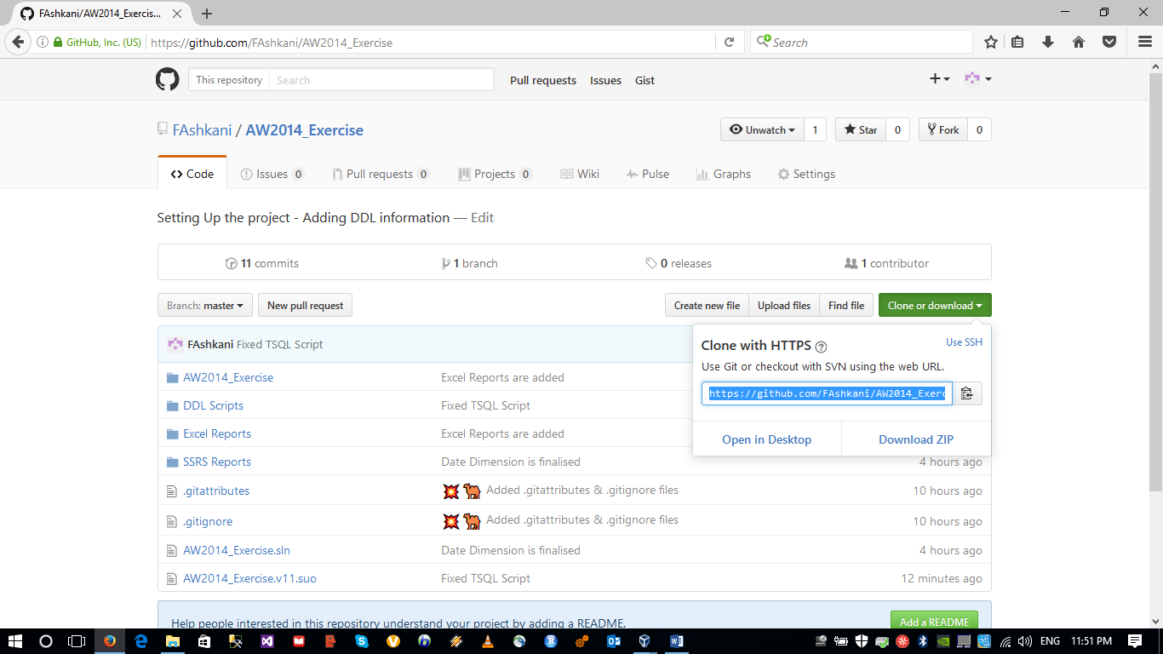

1. Brows into ‘DDL Scripts’ folder in your local repository and open ‘GenerateSalesView.sql’ script in SQL server management studio.
2. After executing the script in management studio, you should be able to see ‘v_SalesByProductByCategory’ view in AdventureWorks2014 database: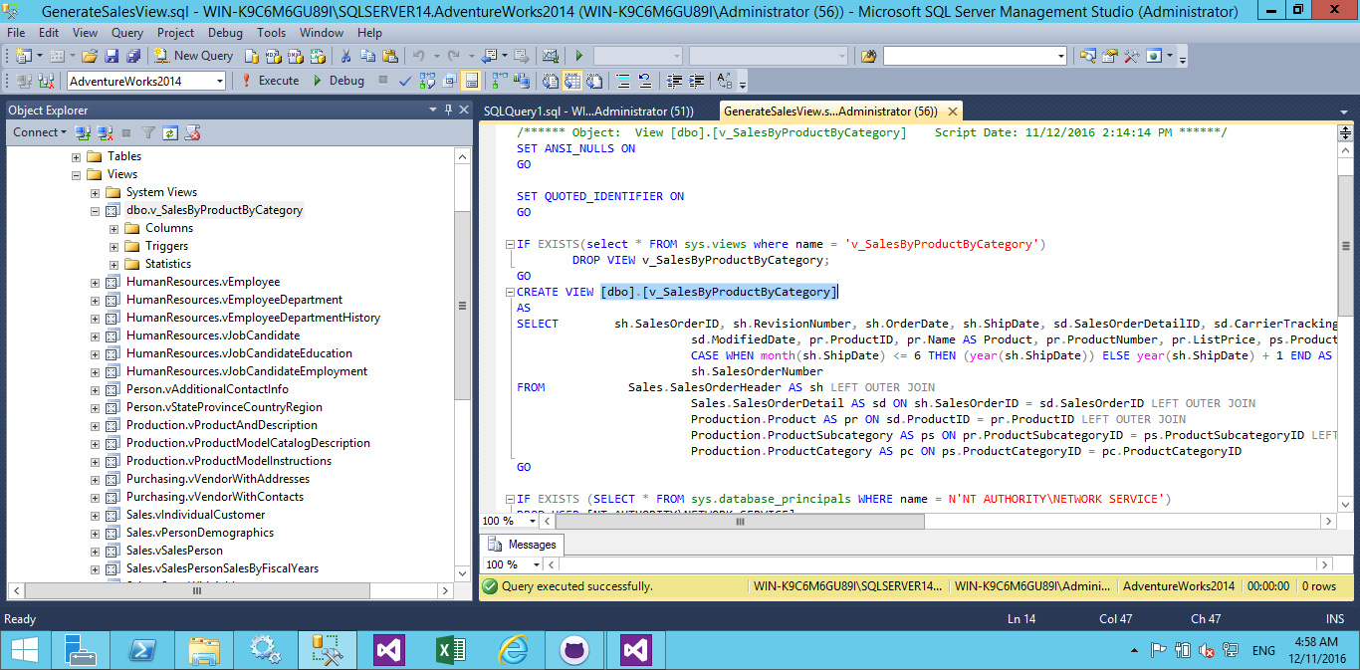
3. Now run SQL Server Data Tools and open ‘AW2014_Exercise’ solution from GitHub repository. This solution contains 2 projects:

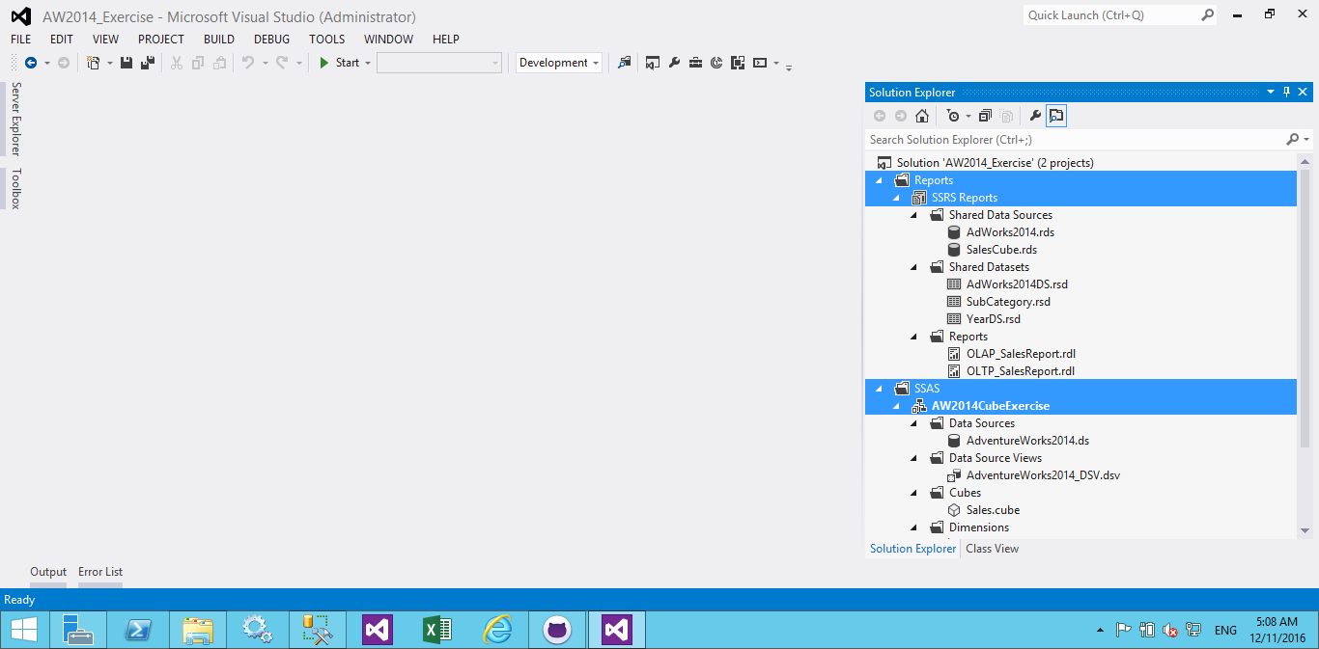

1. Let us continue with SSAS project configuration and installation
2. Double-click on ‘AdventureWorks2014’ and then click on ‘Edit’ button
3. In the next window, enter the SQL Server SSAS instance name and test the connection. Then accept the changes and close all opened windows.
4. Now select SSAS project from solution explorer and press ‘Alt’ + ‘Enter’ keys
5. Go to the ‘Deployment’ tab in project property page and set target SSAS server name

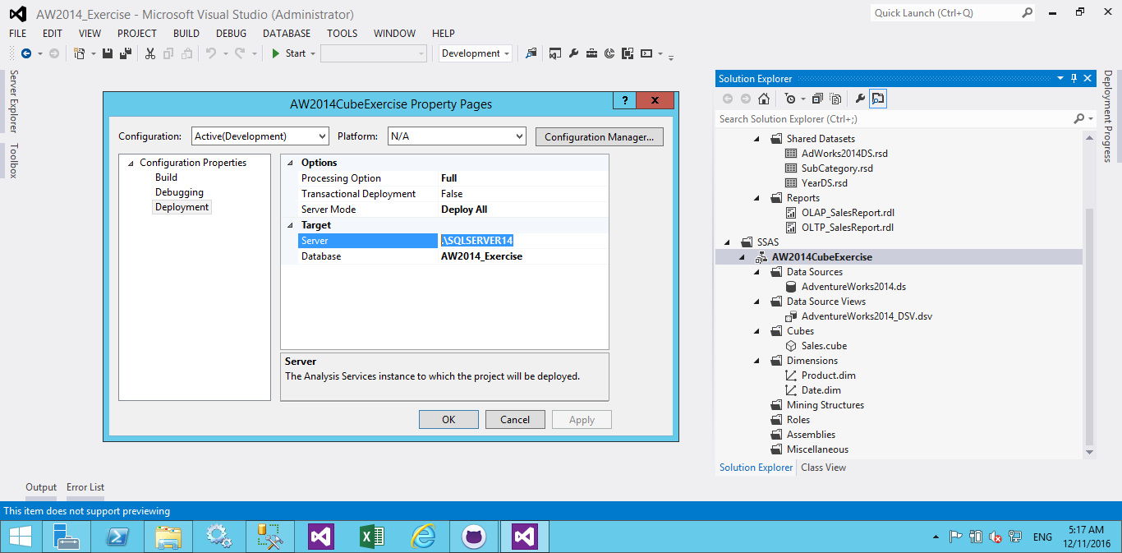

1. SSAS project is ready to be deployed on SSAS instance. Right click on the project name and select ‘Deploy’
2. Now you should be able to open existing dimensions and cube and brows sales cubes information

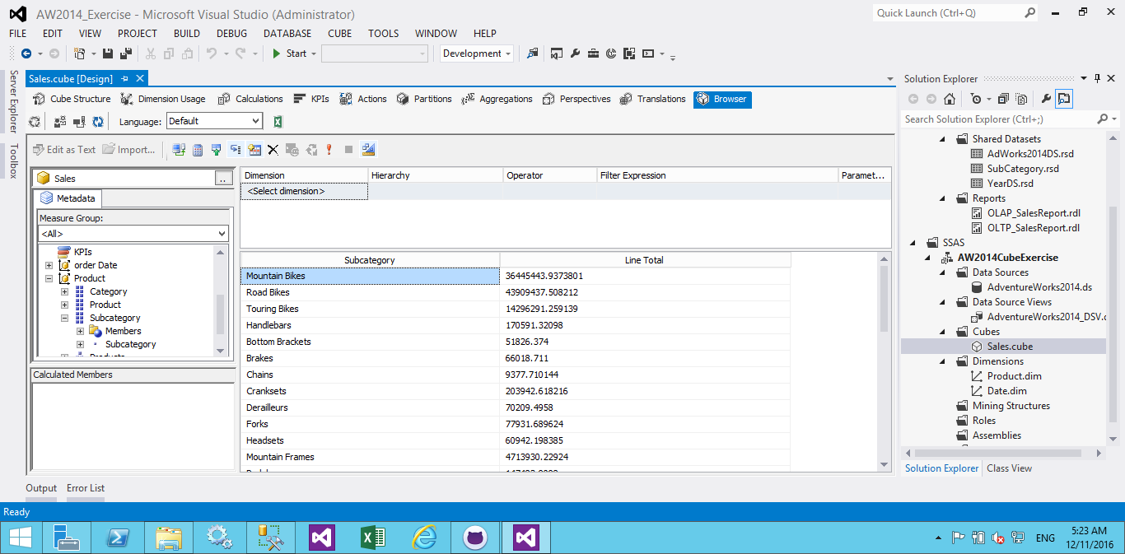

1. Select ‘SSRS Reports’ project from solution explorer and press ‘Alt’ + ‘Enter’ keys
2. In SSRS property page, set destination URL and apply changes

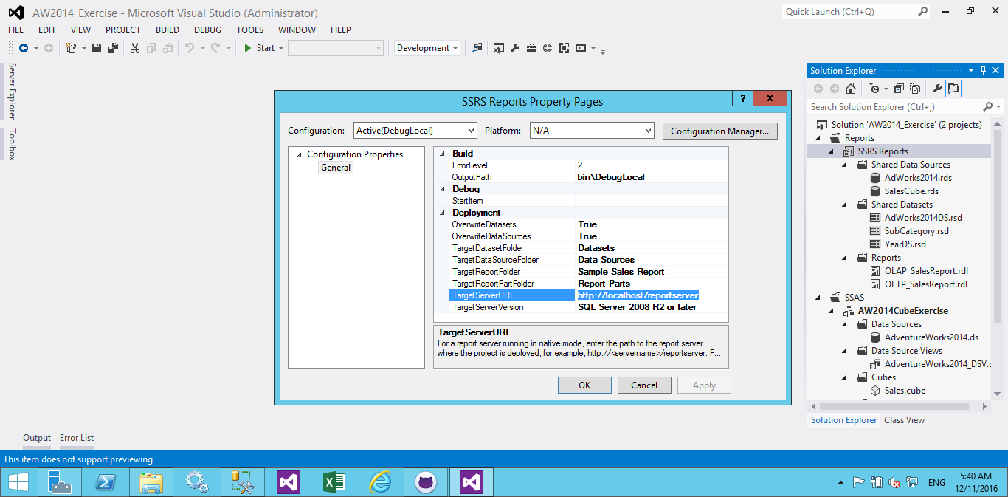

1. Click on ‘AdWorks2014’ shared data source and then click ‘Edit’ button from data source property page and set SQL server instance name in the next window

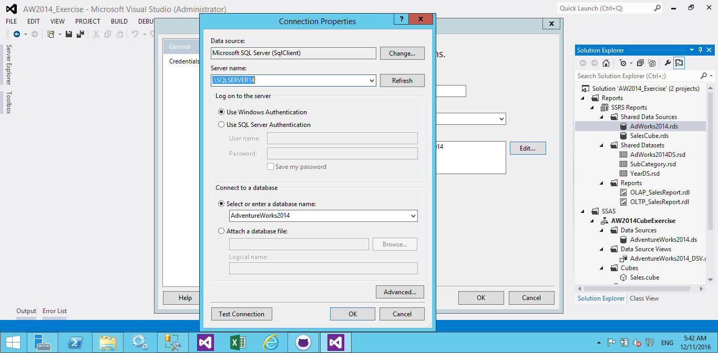

1. Repeat step 15 for ‘SalesCube’ dataset to setup SSAS connection string properly

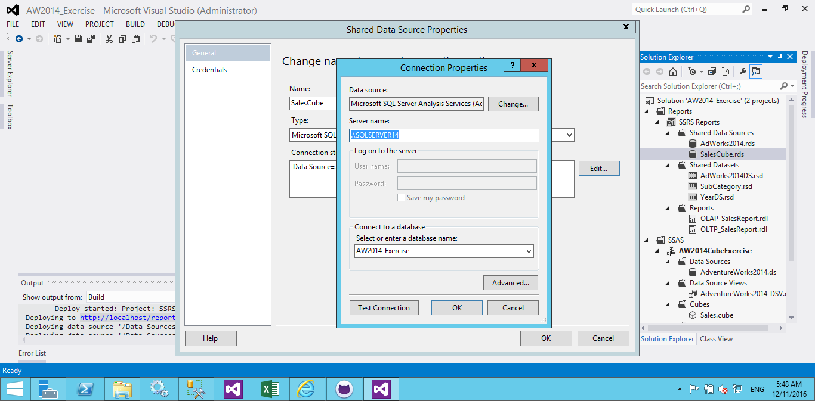

1. It is time to deploy SSRS reports to the target server. Right-click on the SSRS project name and then select ‘Deploy’
2. Now you should be able to see two reports in SSRS reports URL: ‘OLAP_SalesReport’ which reads the information from Sales Cube and ‘OLTP_SalesReport’ which retrieves its data from the view that have been created at step 4

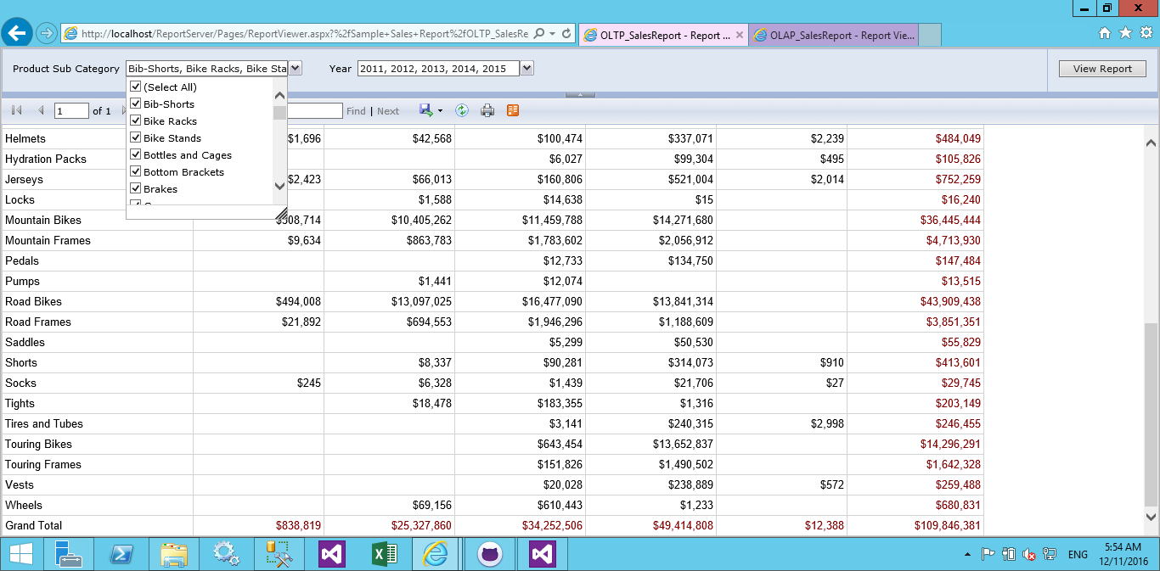

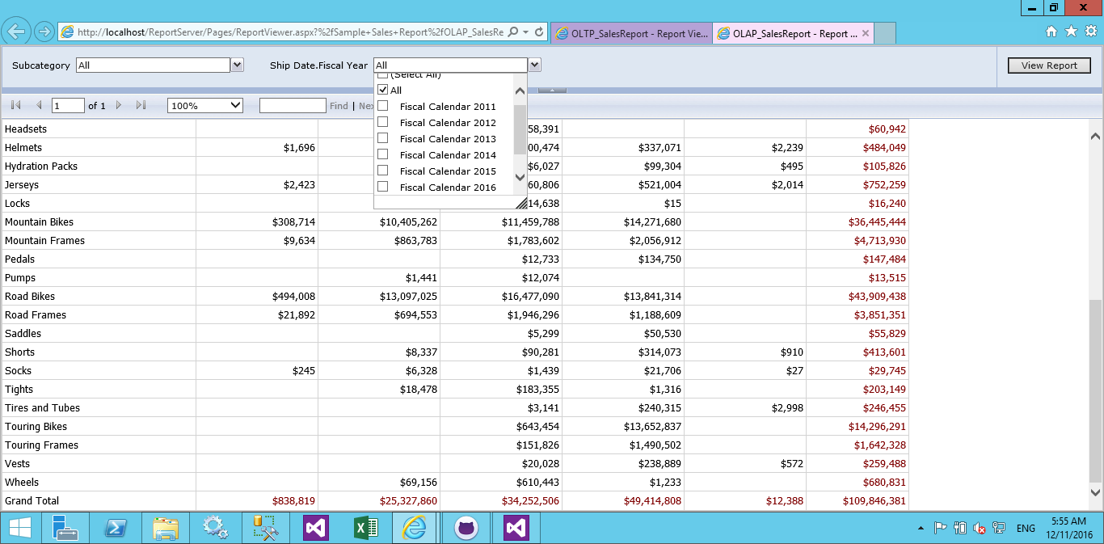

1. As you can see in the above pictures, both reports have parameters to select ‘Subcategories’ and ‘Financial Years’ from drop-down lists
2. The last folder of the repository contains two Excel reports that have been generated using same data sources as SSRS reports. As you can see, all the generated reports are reconciling with the original Excel report file.